## S.5.4 Trait heatmaps

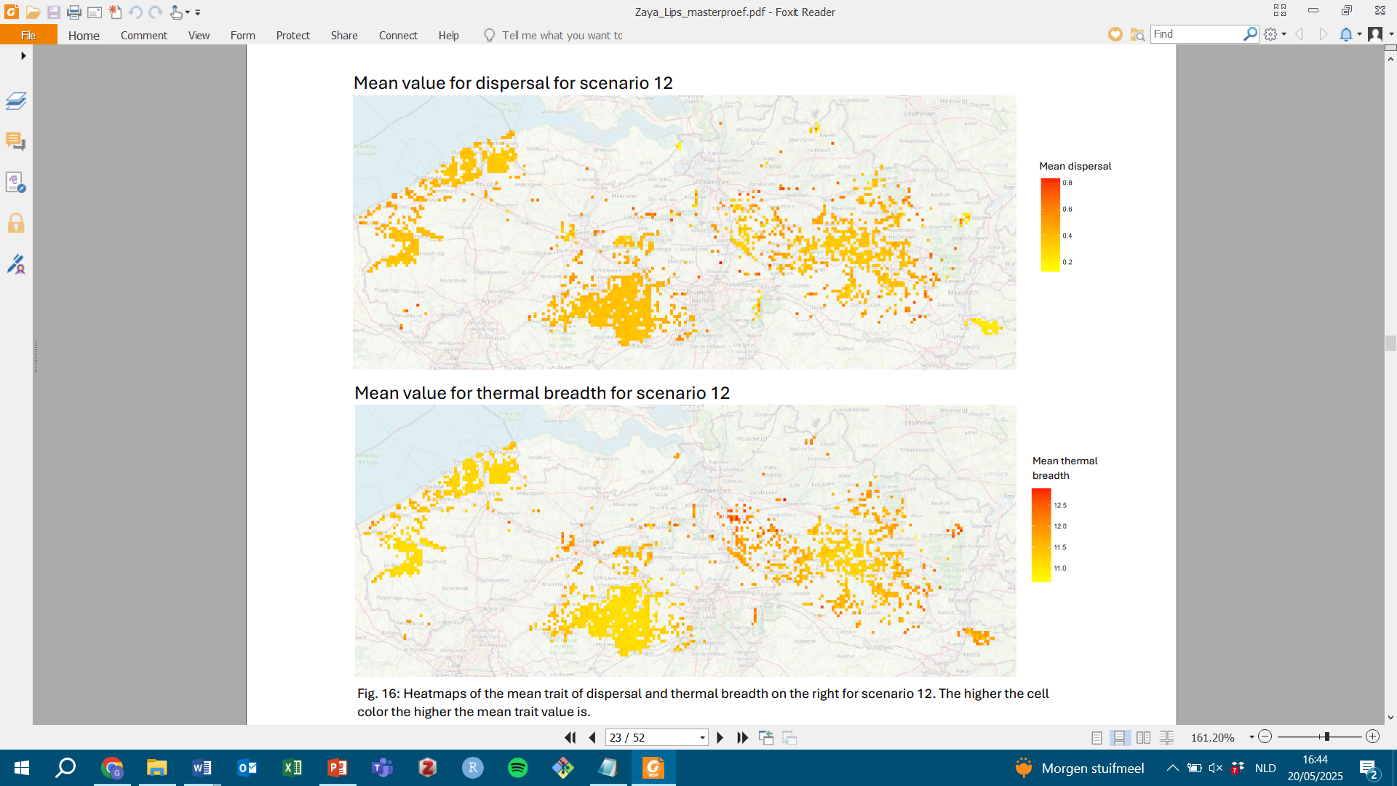

**(a)**

**(b)**

*Figure S.5.4: heatmaps showing mean trait values for (a) dispersal and (b) thermal breadth at the cell level in the all grassland landscape at temperature 15.05 °C. Darker colours indicate higher trait values.*